GLCA: Teaching Writing to Multilingual Writers, College of Wooster, November 1-3, 2019
Assignment Design and Scaffolding
Student Activities: Sample Scaffolded Writing Activities

Considerations:
These activities are designed to be completed over a two-week period. Together, they form a scaffold for students to produce an argumentative paper using analysis. Faculty should design and assign an argumentative prompt to get students thinking. The first activity serves as a rough brainstorm and gets students generating content for the paper, and thus scaffolds the descriptive writing that forms the backbone of the paper. The second activity raises students’ awareness of the difference between content and analysis of that content, and afterwards students have a template to “transform” the content they listed in Activity 1 into analytical writing. The third activity raises students’ awareness of how to elevate analysis into a sophisticated argument, and then also provides a template for transforming the analytical writing from Activity 2 into argumentative writing.
These activities would be especially good for students to complete in pairs/small groups, and Activity 1 would be especially interesting to discuss during class time and might even provide faculty with insight into areas of the prompt that are unclear for students.
At the end is a student handout on helpful language for each of the three styles of writing.
Activity #1
What is Descriptive Writing? Breaking down your Assignment Prompt
Write out (or copy and paste) the assignment prompt here:

Underline all of the information you will have to provide. Look for information questions (who, what, where, when, why) as well as any instructions to bring in course materials.
Use the space below to expand on what you underlined. What specific pieces of information will you provide for each underlined area? Remember, “information” can be data, evidence, statistics, but can also include definitions, citations, and the opinions of others.
Area #1

Area #2

Area #3

Area #4

Area #5

Additional information I think will be helpful:

Scaffolded Activity #2
What is Analytical Writing? Setting the Stage
Before you begin writing, let’s learn about the structure and language of analytical writing. Study the sample of analytical writing here. In particular, notice the “abstract noun groups” and how they are “unpacked”.

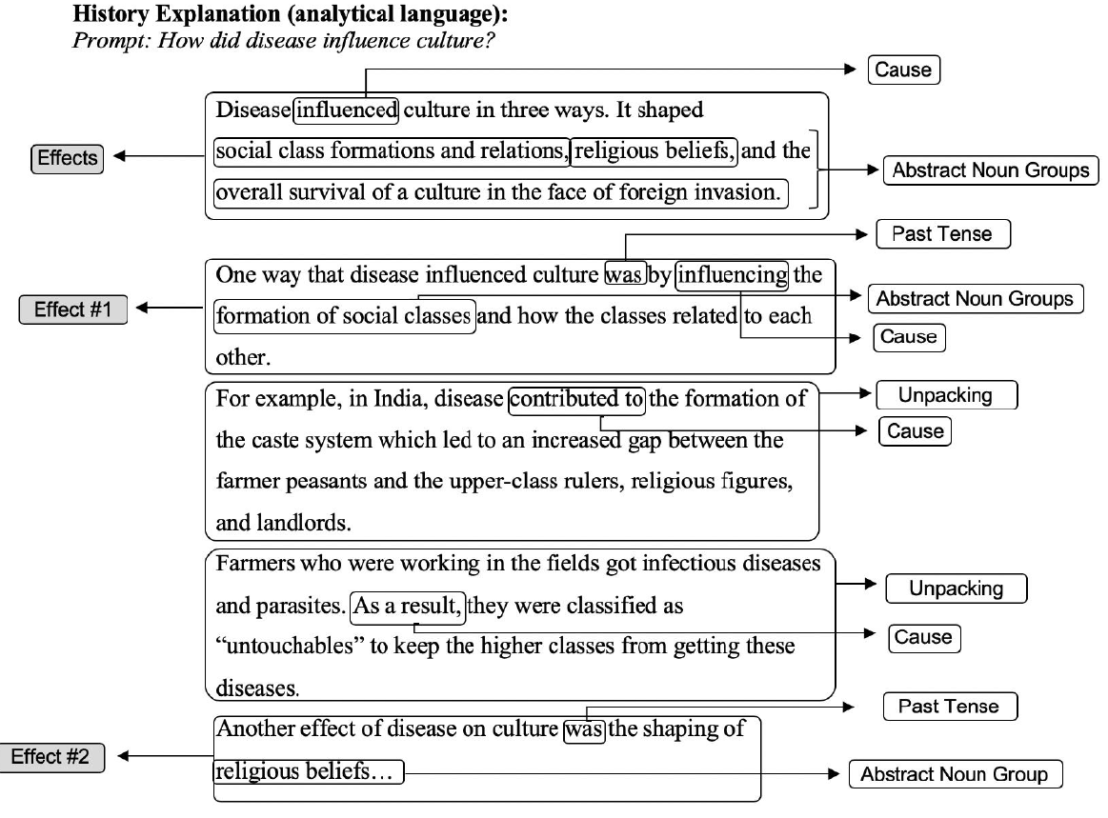
Pessoa, S., Mitchell, T. D., Gomez-Laich, M. P., Maune, M., & Miller, R. T. (2019). Scaffolding student argumentative writing across the disciplines through explicit instruction. Atlanta, GA: TESOL 2019 International Convention.

Now, take a look at what you wrote down on your handout for Activity #1. The information you listed for each area in Activity #1 is what needs to be given an analytical “label”. Write out full sentences with information about one of the areas from Activity 1 the space below.
Area from Activity 1:

Information Sentence #1:

Information Sentence #2:

Information Sentence #3:

Information Sentence #4:

Next, write out a sentence that will categorize all the information you’ve written out. In other words, how does it all relate together? Or, why as a student in this subject/course/for this assignment do you need to care about this information? This should be similar to the “abstract noun groups” you noticed in the above history text example. Consider your information from a disciplinary point of view.

How these pieces of information can be seen together (your analysis):

Put this sentence at the beginning of your paragraph, below before the information sentences. Then, before each information sentence, write how it logically connects to the one before it. For example, are you providing a similar/contrasting piece of information, an example, an extension, a cause/effect, a condition, the purpose, something else? Your final paragraph might look like this:

Analytical sentence giving a disciplinary viewpoint on how the information in this paragraph will all pull together into one category. Transition like “first”, Information about this area with lots of details and description. Transition like “additionally”, more Information about this area with lots of details and description. Transition like “moreover”, more Information about this area with lots of details and description. Transition like “therefore”, more Information about this area with lots of details and description, and possibly re-stating the analysis from the first sentence.

Activity #3:
What is Argumentative Writing? Going Beyond
Before you begin writing, let’s learn about the structure and language of argumentative writing. Study the sample of argumentative writing here. In particular, notice how the “abstract noun groups” (analysis) support a conclusion that the writer draws about the topic, both in the introductory paragraph and also at the beginning and end of each body paragraph.

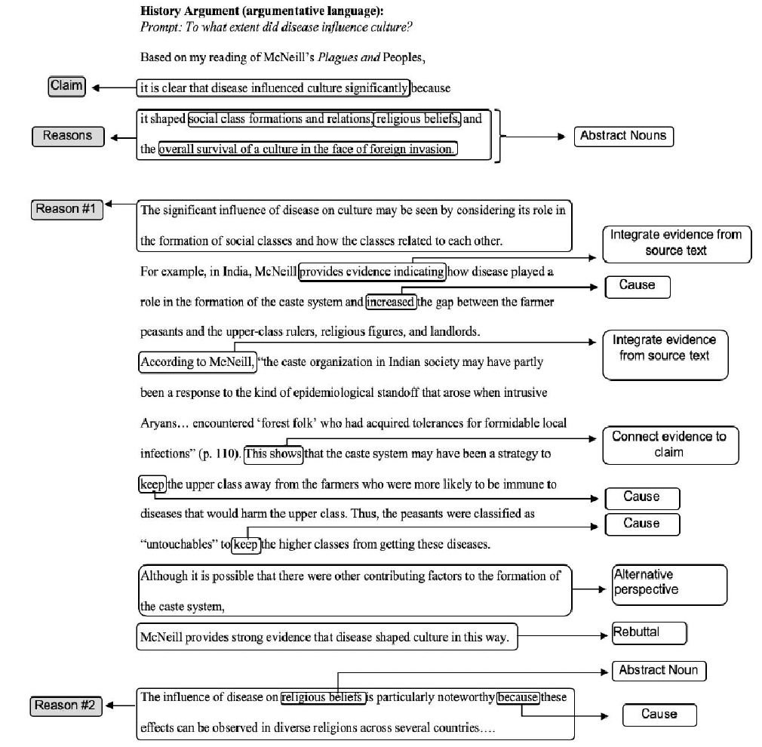
Pessoa, S., Mitchell, T. D., Gomez-Laich, M. P., Maune, M., & Miller, R. T. (2019). Scaffolding student argumentative writing across the disciplines through explicit instruction. Atlanta, GA: TESOL 2019 International Convention.

Now, return to your assignment prompt. What kind of claim can you make about the information you’re being asked to discuss?

It’s time to add to and edit the analytical paragraph you wrote in Activity #2. For each paragraph, modify the first sentence to show how your understanding of the information (your analysis) can be used to support your claim. You may also want to write at least one sentence towards the end of the paragraph that re-states that claim for your readers. Feel free to create new analytical groupings/categories for your information if you feel it would better support your claim.
What I think my Analysis Shows (Claim)
____________________________________________________________________________________.

Your paragraph may now look something like this:
Transition indicating reason like “One reason that supports my claim is” Analytical sentence giving a disciplinary viewpoint on how the information in this paragraph will all pull together into one category. Transition like “first”, Information about this area with lots of details and description. Transition like “additionally”, more Information about this area with lots of details and description. Transition like “moreover”, more Information about this area with lots of details and description. Transition like “therefore”, more Information about this area with lots of details and description, and re-stating the reason this analysis from the first sentence supports your claim.

Helpful Language for Description Analysis and Argumentation

Helpful Language for Creating Descriptive/Informational Sentences
“I see that…” (Evidence) or “I know that…” (Course Concepts)
Observes
Points out
According to
As …. notes
Indicates that
Simple sentences, i.e. “Social attraction theory postulates that personality is a force that draws individuals together.” or “In 2008, a record number of voters turned out for the presidential election.”

Helpful Language for Creating Analytical Sentences
Pessoa, S., Mitchell, T. D., Gomez-Laich, M. P., Maune, M., & Miller, R. T. (2019). Scaffolding student argumentative writing across the disciplines through explicit instruction. Atlanta, GA: TESOL 2019 International Convention

Helpful Language for Drawing Conclusions to Support a Claim/Argument
Analytical Conclusion Claim  “I conclude that…” |  | Analytical Observation Claim  “I see that…”
Therefore | Shows | Seems
For these reasons | Means | Might
It follows that | Demonstrates | May
Given | Predicts | Appears
Consequently | Will | Is
Accordingly | Evidently | It is probable that
It is reasonable to conclude that | Suggests that | Likely
Arguably | Indicates that | Clearly

