GLCA: Teaching Writing to Multilingual Writers, College of Wooster, November 1-3, 2019

Assignment Design and Scaffolding, Carla Reyes and Linda Weaver

Faculty Resource: Tips, Templates, and Samples for Designing a Writing Prompts and Rubrics
Rationale
Research into the design of writing prompts indicates that a variety of factors can influence the accessibility and comprehensibility of the assignment expectations for multilingual international students. An obvious example is that the language can obscure meaning for such a student. Faculty designing writing prompts ought to write in way that is “transparent in vocabulary and syntax,” meaning short sentences with few embedded clauses (hint: avoid the word “that” and use imperative sentences) and no rhetorical questions, idioms, or cultural references/examples, which require additional knowledge beyond the literal meaning of the language to fully understand (Kroll & Reid, 1994). Furthermore, certain words have been shown to more effectively engender certain rhetorical responses over other more commonly used phrases like “discuss” and “analyze,” both for native English speakers and multilingual writers (Miller, Mitchell, & Pessoa, 2016).
In addition to linguistic variables, faculty should also consider the cognitive load of their writing prompts. This includes how many rhetorical tasks are being communicated to the students (Kroll & Reid, 1994). For example, if the expected student text is one that shows knowledge transformation, the wording of the prompt should be as streamlined to that end as possible and should not contain additional questions that are often provided by faculty simply to stimulate students’ thinking but end up overwhelming the students and causing difficulty in text organization and rhetorical prioritization (Frodesen, Gough, & Lashmet, 2019). Another way to reduce the cognitive load of a prompt that is especially helpful for multilingual international students is to create prompts for subsequent assignments that are structured as much as possible in parallel in wording and format to those that have been previously assigned (Kroll & Reid, 1994). This is because multilingual international students are keenly aware of their “outsider” and novice writer statuses, and to compensate for insufficient linguistic and rhetorical background knowledge they will often draw upon whatever pre-existing knowledge they have, which often translates into transposing past English writing experiences onto current assignments and repeating whatever was positively evaluated, regardless of what is actually expressed in the writing prompt at hand (Cheng, 2019).
Considerations
When deciding which prompt template to use, pay careful attention to the selection of source text/materials being paired with a prompt. Research has shown that source texts which present information in chronological order and source texts which already put forth claims supported by evidence are seen by students as credible arguments that simply need re-framing and re-telling, rather than inviting additional analysis and argumentation, meaning that assignments that are paired with these types of source materials are more likely to result in knowledge display texts by the students (Miller, Mitchell, & Pessoa, 2016). Conversely, paired materials that are more similar in nature to primary sources have been found to engender knowledge transformation texts, as the lack of any overt claim in the source prompts writers to do something with that information.
Therefore, when selecting from the prompt templates below, consider what the ultimate objective of the assignment is. If it is a knowledge transformation assignment, design the prompt in that way, and avoid including language from the descriptive prompt template. Instead, the “lower-order concerns” that you wish to see addressed in a knowledge transformation essay can be scaffolded by lower-stakes writing activities. For example, you may wish to do in-class writing workshops using descriptive or analytical writing prompts before assigning an argumentative or critical prompt as a larger paper.
Tips for Designing a Writing Prompt
- Consider if the purpose of the assignment is for knowledge display (summary, explanation, synthesis) or knowledge transformation (analysis, claim, critique).
- For knowledge transformation assignments, avoid using wh- question words, which are more likely to result in reporting of information.
- For knowledge transformation assignments, avoid verbs such as “describe,” “explain,” and “discuss,” which are more likely to result in reporting texts, and instead opt for words like “demonstrate” or “argue,” which imply reasoning for a position based on evidence.
- For knowledge transformation assignments, consider using the direct-address “you.” This word is considered to engender argumentative or critical positions because it stimulates the formation of personal opinions.
- For knowledge transformation assignments, consider incorporating degree words like “how much” or “to what extent” to cue evaluative rhetorical expression.
- Avoid the use of rhetorical questions, or multiple questions that are designed to stimulate the same response (i.e., avoid “in other words…”).
- Streamline how many tasks/commands are given.
- Use as simple sentences as possible, and avoid using multiple embedded clauses within one sentence.
- Avoid introducing new ideas as helpful “examples,” and instead reference material that has already been covered.
- Avoid the use of idioms and cultural metaphors.
- As much as is possible, maintain similar wording and structure of writing prompts throughout your entire course.
- Encourage risk-taking; feel free to include a statement such as You will not be penalized for using an authoritative voice, but you may lose points if you are not assertive enough!

Tips for Designing a Writing Assignment Rubric
- Keep the assignment prompt and your course learning objectives/outcomes at hand for easy reference! (A consultation with your institution’s director of educational assessment may be helpful, as well, if you’re unfamiliar with how to align these.)

- Categorize and evaluate knowledge display (this could be “evidence,” “definitions,” “outside sources,” “course materials,” etc.) and knowledge transformation (“course concepts,” “analysis,” “critique,” “claim”) separately.
- Be specific about what using disciplinary conventions includes (if you even have that as a category). Correct APA/MLA citation? Format and style? Preference for avoiding passive voice? Certain types of verbs over others? Disciplinary organization/structure/subsections? Punctuation styles?

- If students will be assessed on standard grammar and vocabulary usage, include a small, separate category.

- Consider the “highest order” goal(s) of the assignment and weight accordingly.

Template for Discussion Prompt
A.
- What does
information from source text(s)/course materials
2. tell us about
related course concept/new information to compare it to?

B.
- Discuss the factors that led to/influenced/contribute to
information from source text(s)/course materials.

C.
- Explain how
information from source text(s)/course materials.
Template for Analysis Prompt
A.
- In our class, we have looked at
specific cases/details/information.
2. Demonstrate how
certain course concepts/disciplinary frames
3. apply to
specific cases/details/information.

B.
- In our class, we have looked at
specific cases/details/information.
2. Compare and/or contrast
specific cases/details/information,
3. applying
certain course concepts/disciplinary frames.

Template for Argumentative Prompt
- In our class, we have been studying
- Disciplinary Concepts X, Y, and Z
- Source Text(s) (preferably a primary text without its own internal argumentation).

- Using
Materials that should serve as the basis of their evidence,
- argue
Degree/evaluation cue (i.e., to what degree)
you believe y to be.

- Organize your argument
according to the disciplinary framework/structure appropriate.

Sample Rubric for Analytical Assignment
A.
Analysis | Organizes and synthesizes evidence to reveal insightful patterns, differences, or similarities related to focus. Information from source(s) is thoroughly interpreted/elaborated. | Organizes evidence to reveal important patterns, differences, or similarities related to focus. Information from source(s) is sufficiently interpreted/elaborated. | Organizes evidence, but the organization is not effective in revealing important patterns, differences, or similarities. Information from source(s) is interpreted/elaborated some, but not enough to develop a coherent analysis or synthesis. | Lists evidence, but it is not organized and/or is unrelated to focus.
Sources and Evidence | Skillfully uses high-quality, credible, relevant sources to sufficiently report ideas and information that are appropriate for the topic and discipline | Consistently uses credible, relevant sources to sufficiently report ideas and information that are appropriate for the topic and discipline | Demonstrates an attempt to use credible and/or relevant sources to report ideas and information that are appropriate for the topic and discipline | Demonstrates an attempt to use sources to support ideas to report ideas and information that are appropriate for the topic
Genre and Disciplinary Conventions | Demonstrates detailed attention to and successful execution of a wide range of conventions particular to a specific discipline and/or writing task (s) including organization, content, presentation, formatting, and stylistic choices | Demonstrates consistent use of important conventions particular to a specific discipline and/or writing task(s), including organization, content, presentation, and stylistic choices | Follows expectations appropriate to a specific discipline and/or writing task(s) for basic organization, content, and presentation | Attempts to use a consistent system for basic organization and presentation.
Control of Syntax and Mechanics | Mostly uses standard grammar and disciplinary vocabulary to communicate meaning to readers, with few errors that inhibit comprehension of argument/evidence. | Uses standard grammar and some disciplinary vocabulary to communicate meaning to readers, with occasional errors that inhibit comprehension of argument/evidence. | Uses language that generally conveys meaning to readers, although contains occasional errors that inhibit comprehension of argument/evidence. | Little use of disciplinary language. Uses language that often impedes meaning because of errors in usage.
This rubric was created using the Association of American Colleges and Universities (AAC&U) Inquiry and Analysis, Critical Thinking, and Written Communication VALUE Rubrics. Retrieved from https://www.aacu.org/value-rubrics
Sample Rubric for Critical Analysis/ Argumentative Assignment
A.
Analysis | Organizes and synthesizes evidence to reveal insightful patterns, differences, or similarities related to focus. Information from source(s) is thoroughly interpreted/elaborated. | Organizes evidence to reveal important patterns, differences, or similarities related to focus. Information from source(s) is sufficiently interpreted/elaborated. | Organizes evidence, but the organization is not effective in revealing important patterns, differences, or similarities. Information from source(s) is interpreted/elaborated some, but not enough to develop a coherent analysis or synthesis. | Lists evidence, but it is not organized and/or is unrelated to focus.
Conclusions | States a conclusion that is a logical extrapolation from the inquiry findings. | States a conclusion focused solely on the inquiry findings. The conclusion arises specifically from and responds specifically to the inquiry findings. | States a general conclusion that, because it is so general, also applies beyond the scope of the inquiry findings. | States an ambiguous, illogical, or unsupportable conclusion from inquiry findings.
Student's position (perspective, thesis/hypothesis) | Specific position (perspective, thesis/hypothesis) is imaginative, taking into account the complexities of an issue. Others' points of view are synthesized within position (perspective, thesis/hypothesis). Conclusions are consistently linked through logical connectors to the analysis. | Specific position (perspective, thesis/hypothesis) takes into account the complexities of an issue. Others' points of view are acknowledged within position (perspective, thesis/hypothesis). Conclusions are often linked through logical connectors to the analysis. | Specific position (perspective, thesis/hypothesis) acknowledges different sides of an issue. Conclusions are poorly linked through logical connectors to the analysis. | Specific position (perspective, thesis/hypothesis) is stated, but is simplistic and obvious.  AND/OR  Specific position is not linked through logical connectors to the analysis.
Sources and Evidence | Demonstrates skillful use of high-quality, credible, relevant sources to develop ideas that are appropriate for the discipline and genre of the writing | Demonstrates consistent use of credible, relevant sources to support ideas that are situated within the discipline and genre of the writing. | Demonstrates an attempt to use credible and/or relevant sources to support ideas that are appropriate for the discipline and genre of the writing. | Demonstrates an attempt to use sources to support ideas in the writing.
Genre and Disciplinary Conventions | Demonstrates detailed attention to and successful execution of a wide range of conventions particular to a specific discipline and/or writing task (s) including organization, content, presentation, formatting, and stylistic choices | Demonstrates consistent use of important conventions particular to a specific discipline and/or writing task(s), including organization, content, presentation, and stylistic choices | Follows expectations appropriate to a specific discipline and/or writing task(s) for basic organization, content, and presentation | Attempts to use a consistent system for basic organization and presentation.
Control of Syntax and Mechanics | Mostly uses standard grammar and disciplinary vocabulary to communicate meaning to readers, with few errors that inhibit comprehension of argument/evidence. | Uses standard grammar and some disciplinary vocabulary to communicate meaning to readers, with occasional errors that inhibit comprehension of argument/evidence. | Uses language that generally conveys meaning to readers, although contains occasional errors that inhibit comprehension of argument/evidence. | Little use of disciplinary language. Uses language that often impedes meaning because of errors in usage.
This rubric was created using the Association of American Colleges and Universities (AAC&U) Inquiry and Analysis, Critical Thinking, and Written Communication VALUE Rubrics. Retrieved from https://www.aacu.org/value-rubrics

B.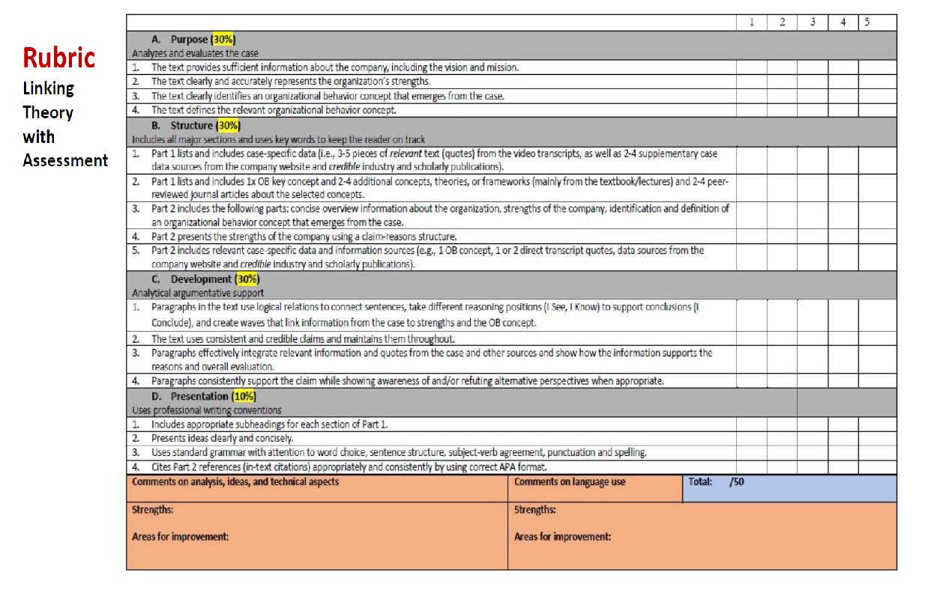
Pessoa, S., Mitchell, T. D., Gomez-Laich, M. P., Maune, M., & Miller, R. T. (2019). Scaffolding student argumentative writing across the disciplines through explicit instruction. Atlanta, GA: TESOL 2019 International Convention.

